ASP.NET Core 8.0 Web API
Aim:
To implement JWT (JSON Web Token) authentication and role-based authorization in an ASP.NET Core Web API application and validate secure access using Postman.
Objectives:
- To implement JWT authentication in ASP.NET Core Web API.
- To generate JWT tokens using an AuthController.
- To secure Web API endpoints using the Authorize attribute.
- To validate API access using Postman.
- To demonstrate role-based authorization using JWT claims.
Tools Required:
- Visual Studio 2026
- ASP.NET Core Web API (.NET 10)
- C#
- Swagger UI
- Postman
Procedure:

Step 1
Configured JWT authentication in Program.cs by adding JWT Bearer authentication and token validation parameters.

Step 2
Created an AuthController to generate JWT tokens with user role and user ID claims.

Step 3
Applied the [Authorize] attribute to the EmployeeController to protect the API endpoints.

Step 4
Generated a JWT token using the GET /api/Auth endpoint in Swagger.

Step 5
Used Postman to access the protected Employee API without a JWT token and verified that the API returned 401 Unauthorized.

Step 6
Used the generated JWT token in the Authorization header (Bearer Token) and verified that the Employee API returned 200 OK.

Step 7
Modified the authorization role to verify role-based access control and observed 403 Forbidden for unauthorized roles and 200 OK for authorized roles.

Figure 1: Visual Studio showing JWT authentication configuration in Program.cs.
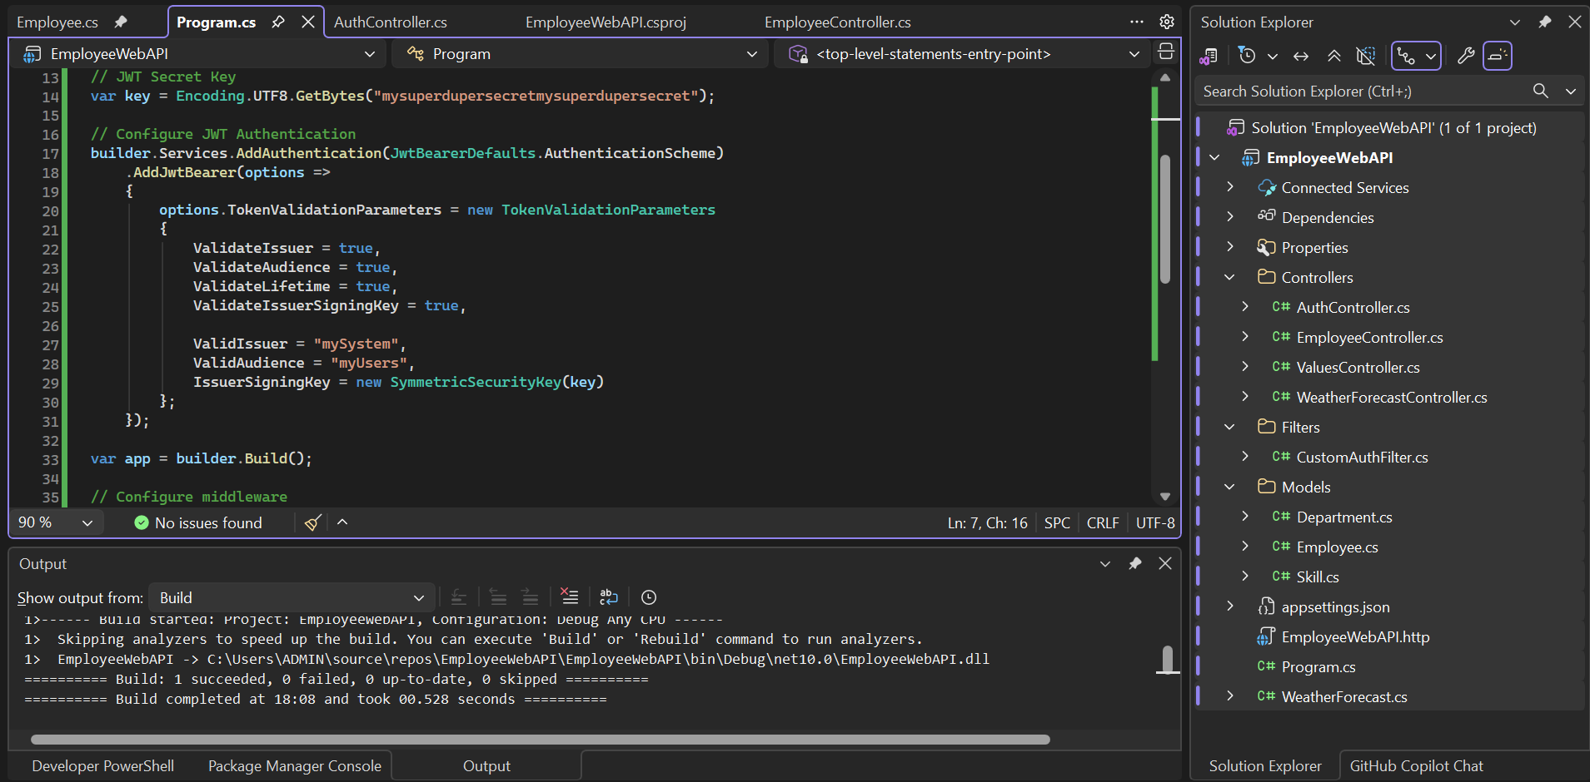
Figure 2: EmployeeController secured using the [Authorize] attribute.
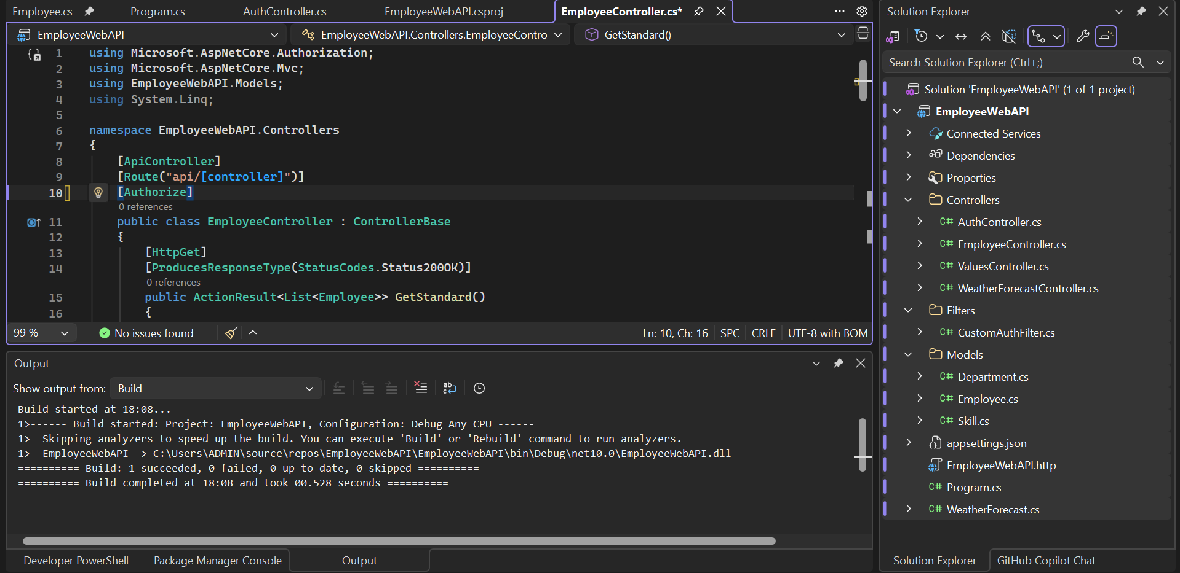
Figure 3: Swagger UI displaying the GET /api/Auth endpoint.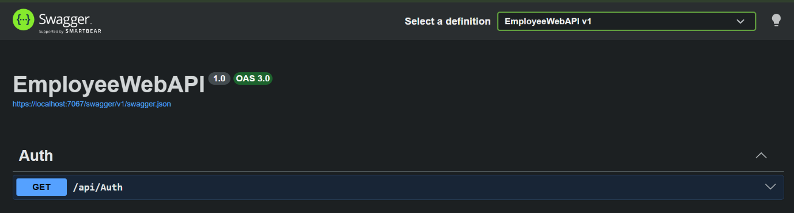

Figure 4: JWT token generated successfully using the GET /api/Auth endpoint.
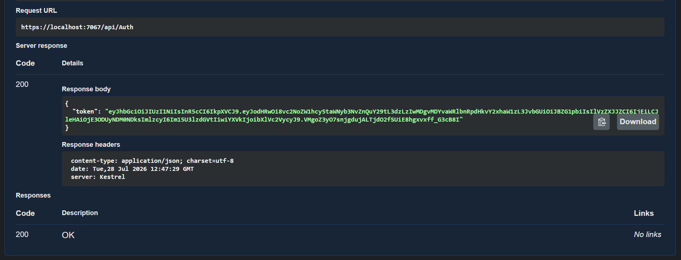

Figure 5: Postman response showing 401 Unauthorized without a JWT token.
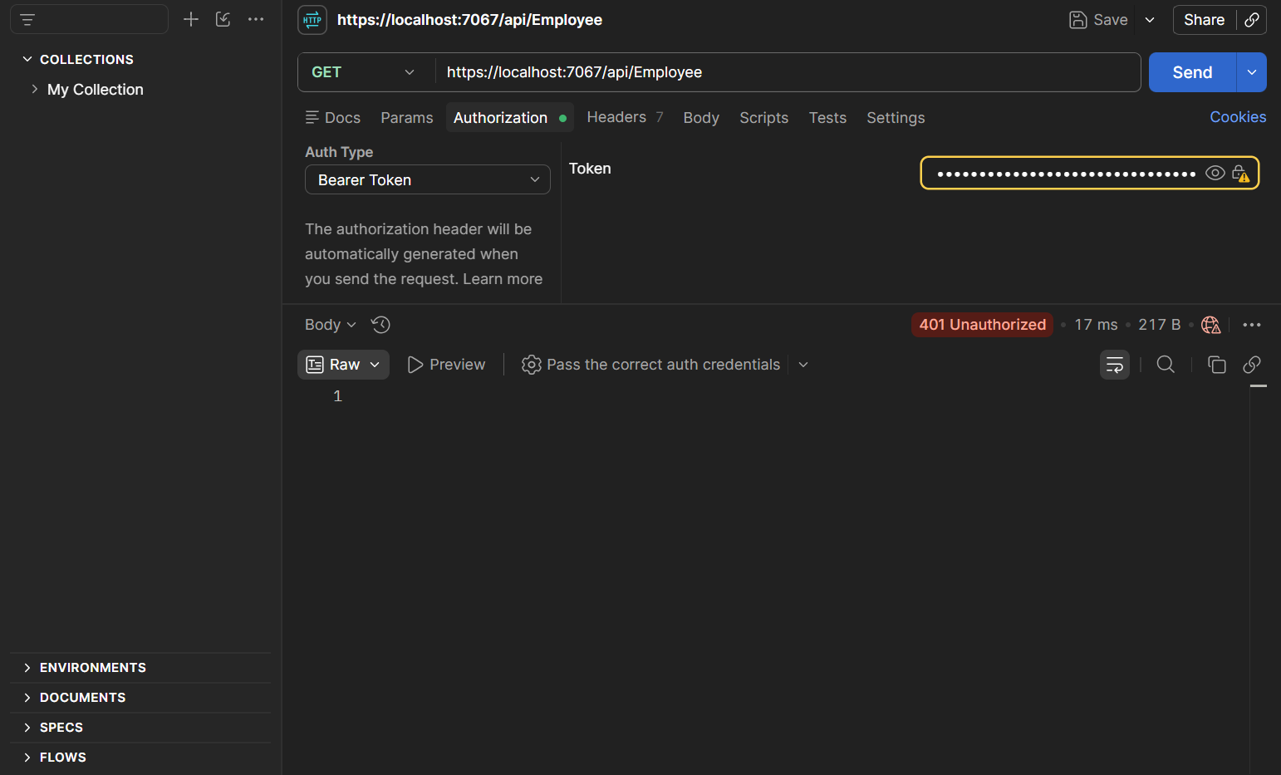

Figure 6: Postman response showing 200 OK after sending a valid JWT Bearer token.
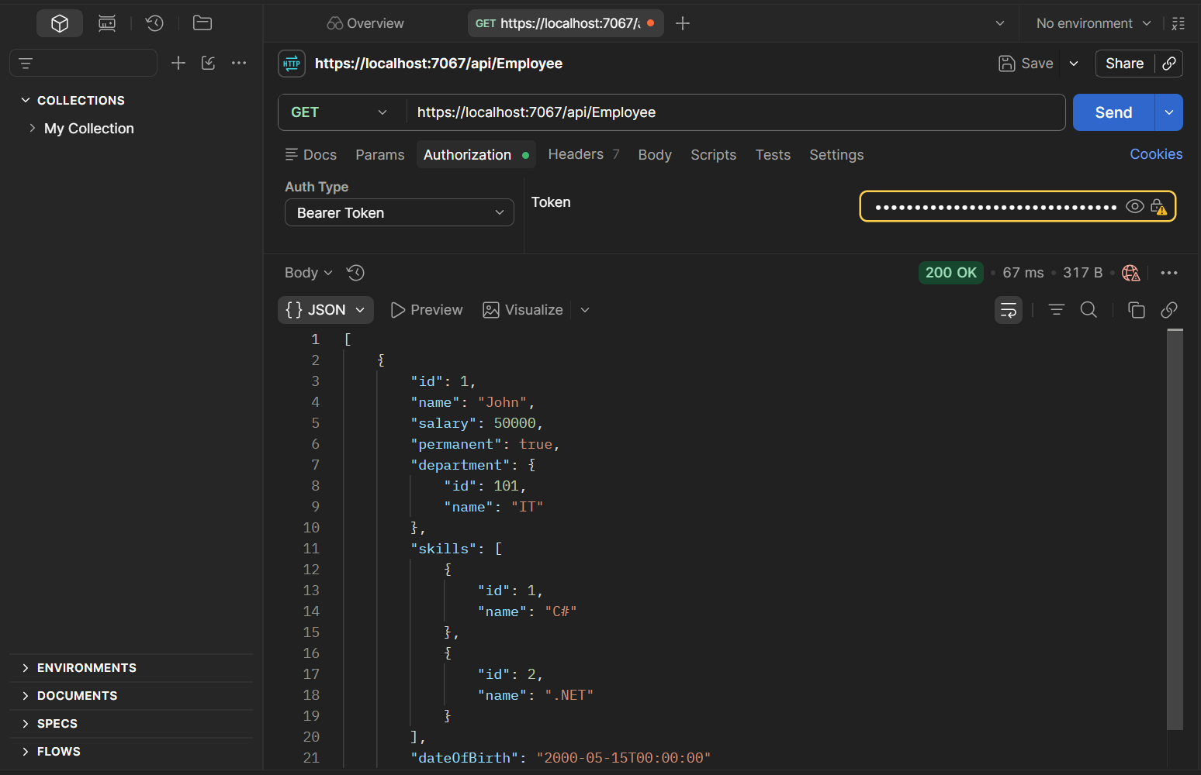

Figure 7: EmployeeController configured with [Authorize(Roles = "POC")].
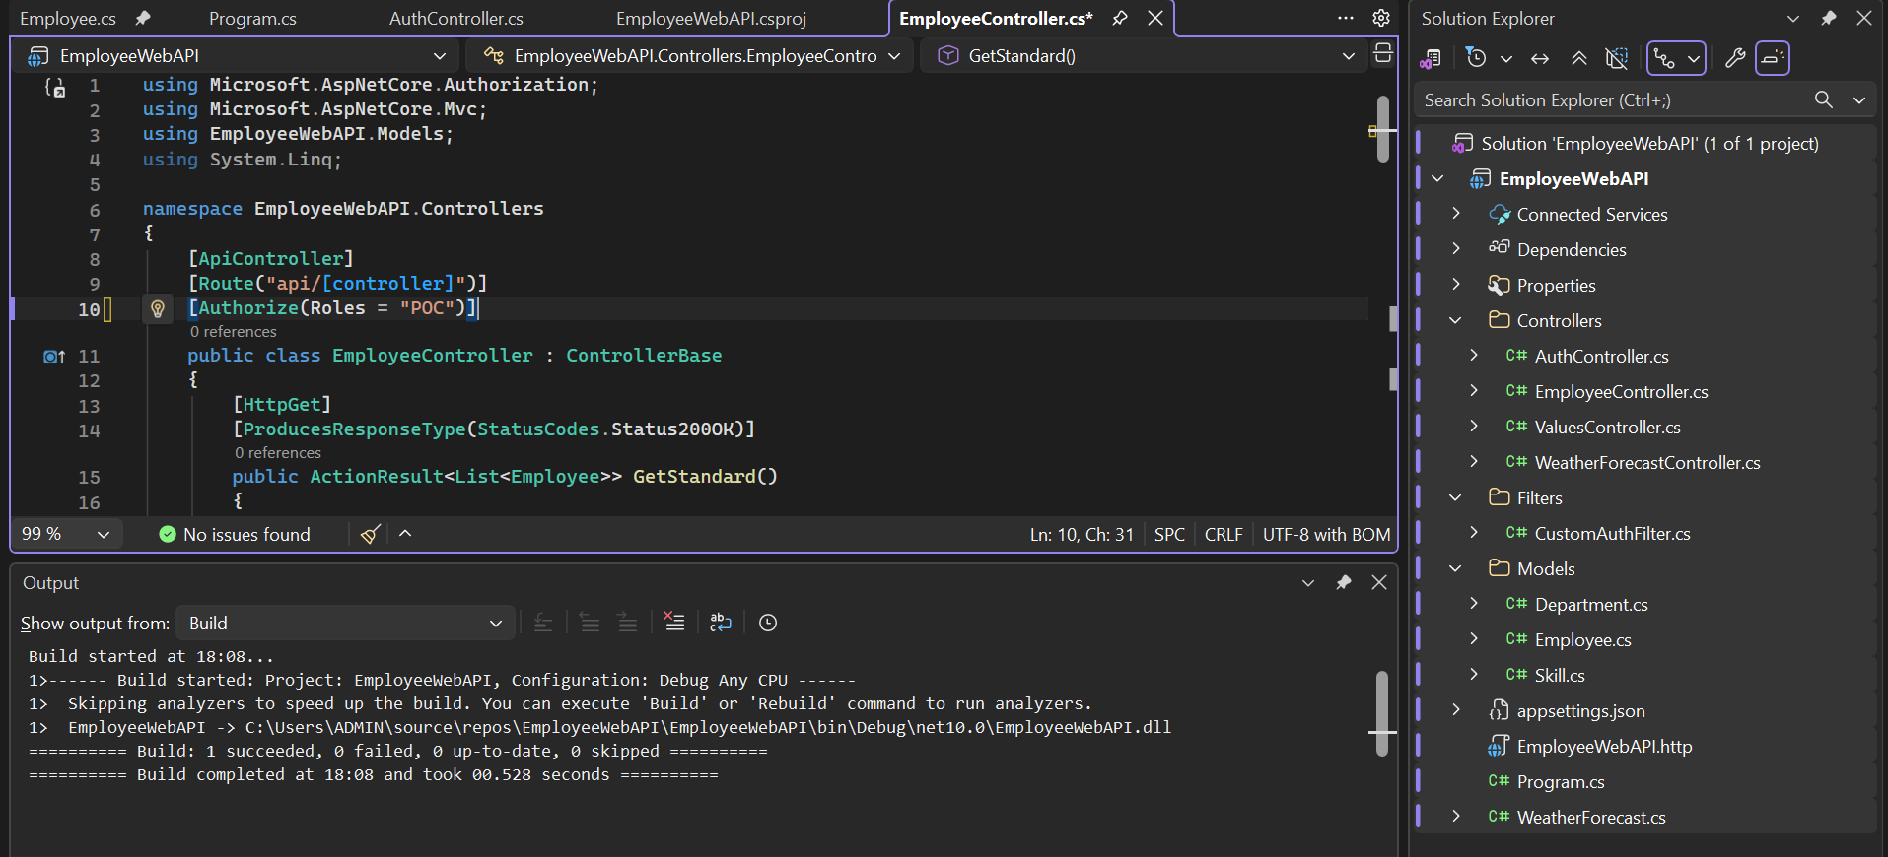

Figure 8: EmployeeController configured with [Authorize(Roles = "Admin,POC")].
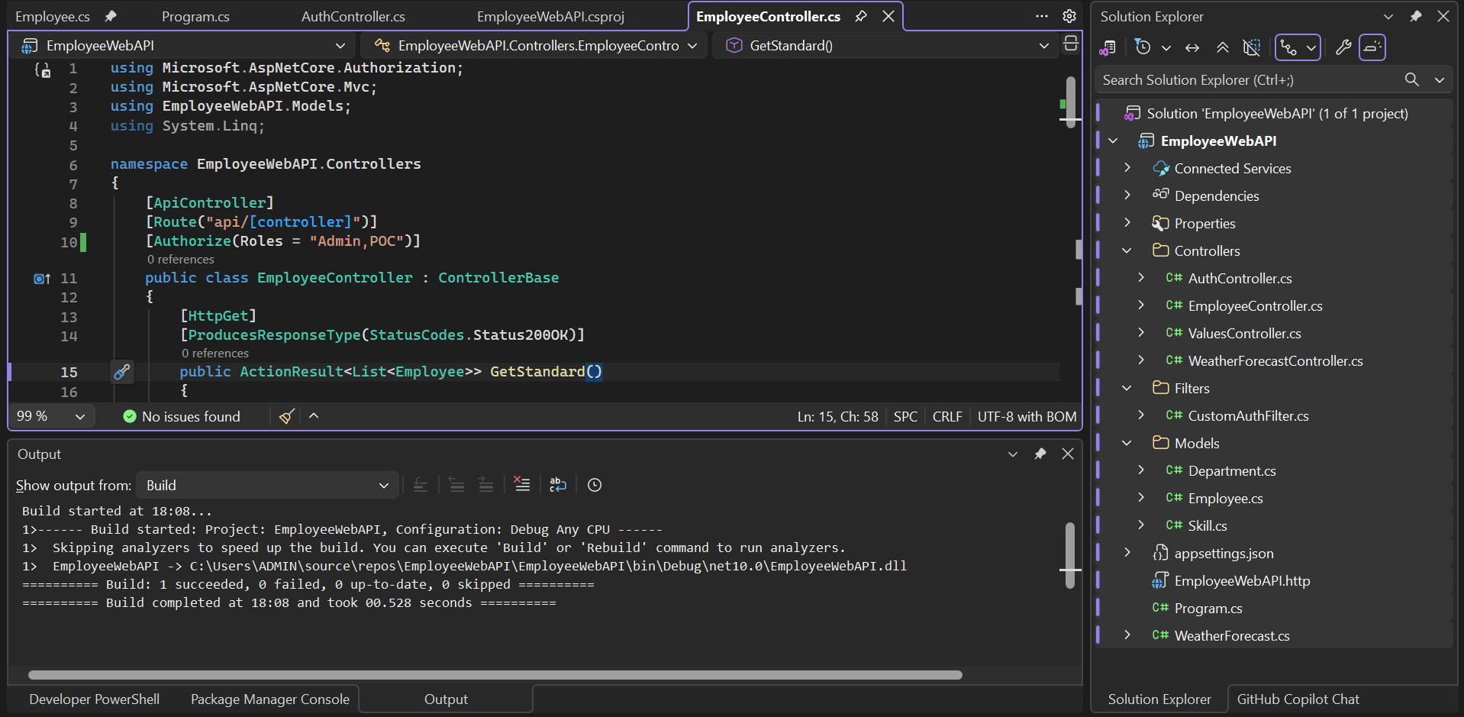

Result:
Successfully implemented JWT authentication and role-based authorization in ASP.NET Core Web API. JWT tokens were generated and validated successfully, unauthorized requests returned 401 Unauthorized, invalid role access returned 403 Forbidden, and authorized requests returned 200 OK, demonstrating secure access control using JWT.

